1: The Draft (The AIM Framework)
Use “Machine English” be sharp and targeted. Do not talk to the AI like a person; talk to it like a computer designed to predict tokens.

A - Actor
Have I explicitly told the model who it is acting as?
- Example: "You are the world's most sought-after resume editor."

I - Input
Have I provided the necessary background data?
- Example: "I am attaching my resume and the specific job description."

M - Mission
Have I defined exactly what I want the AI to do with the input?
- Example: "Review it and give me a bulleted list of 10 specific ideas to improve clarity."

2: Building Context (The MAAP Framework)
The smartest AI is clueless without a map. Ground the model in reality.

M - Memory
Have I summarized previous context or repasted relevant parts of the conversation thread so the AI remembers where we are?

A - Assets
Have I uploaded files, pasted data, or provided specific resources (URLs/text) for the AI to reference?

A - Actions
Have I specified what tools the model should use?
- Example: "Search the web," "Scan this drive," "Write code," or "Create a Notion doc."

P - Prompt
Is the instruction itself clear (incorporating the AIM structure above)?

3: Steering & Debugging
If the answer is generic or wrong, debug your thinking, not the AI.

Steering to Experts (Avoiding Mediocrity)

Avoid the Middle
Did I remove vague requests? (e.g., "How do I manage a team?")

Inject Expertise
Did I ask the AI to use specific mental models, famous frameworks, or specific experts?
- Example: "Explain this using Pixar’s Braintrust model and Satya Nadella’s strategy."

Identify Experts (If unknown)
If I don't know the experts, did I first ask the AI to "List the top experts and research papers on [Topic]" and then feed that back into the prompt?

The "Cheat Codes" (If the output is weak)

Chain of Thought
Did I add: "Think step by step. Show your reasoning, then give the final answer"?

The Verifier
Did I ask: "Ask me three questions that would clarify my intent. Ask one at a time"?

The Refinement
Did I ask: "Before answering, propose two sharper versions of my question and ask which I prefer"?

4: Verification (The Truth Check)
AI is a probabilistic engine, not a truth engine. Don't consume; critique.

Check Assumptions
Did I ask the AI to "List every assumption made and rank them by confidence"?

Check Sources
Did I ask the AI to "Cite two independent sources for each major claim (Title, URL, Quote)"?

Counter Evidence
Did I ask the AI to "Find one credible source that disagrees with your answer"?

Audit Math/Code
Did I ask the AI to "Re-compute every figure and show the math/code"?

Cross-Model Verification
Have I run this same prompt in a different model (e.g., Gemini vs. Claude) to compare the outputs?

5: Adding Taste (The OCEAN Framework)
Stop the output from sounding like generic "vending machine" text. Make it sound like YOU.

O - Original
Does the answer contain non-obvious ideas?
- Prompt Action: "Give me 3 angles no one else has thought about. Label one as 'risky'."

C - Concrete
Are there specific names, numbers, and examples?
- Prompt Action: "Back every claim with one real-world example."

E - Evident
Is the logic visible?
- Prompt Action: "Show your logic in three bullets before providing the final answer."

A - Assertive
Does it take a stance?
- Prompt Action: "Don't tell me what I want to hear. Pick a side, state your thesis, and defend it."

N - Narrative
Does it flow like a story?
- Prompt Action: "Write this like a story: Hook, Problem, Insight, Proof, Action."

Prompting Cheat Sheet!
Original video from The MIT Monk:
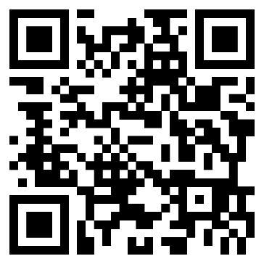

www.youtube.com/watch?v=EWFFaKxsz_s

